PROJECT DESIGN PHASE
TECHNOLOGY STACK(ARCHITERTURE& STACK)
Date | 30/10/2025
Time id | NM2025TMID05890
Project name | Calculating Family Expenses using Service Now
Maximum mark | 4 marks

Definition – Technology Stack (Architecture & Stack)
The Technology Stack refers to the set of technologies, tools, and frameworks used to design, develop, and deploy the Calculating Family Expenses system.
It includes both the architecture (the structural design of how different components interact) and the stack (the specific technologies used in each layer).
This combination ensures that the application is efficient, scalable, secure, and user-friendly for managing and analyzing family expenses.
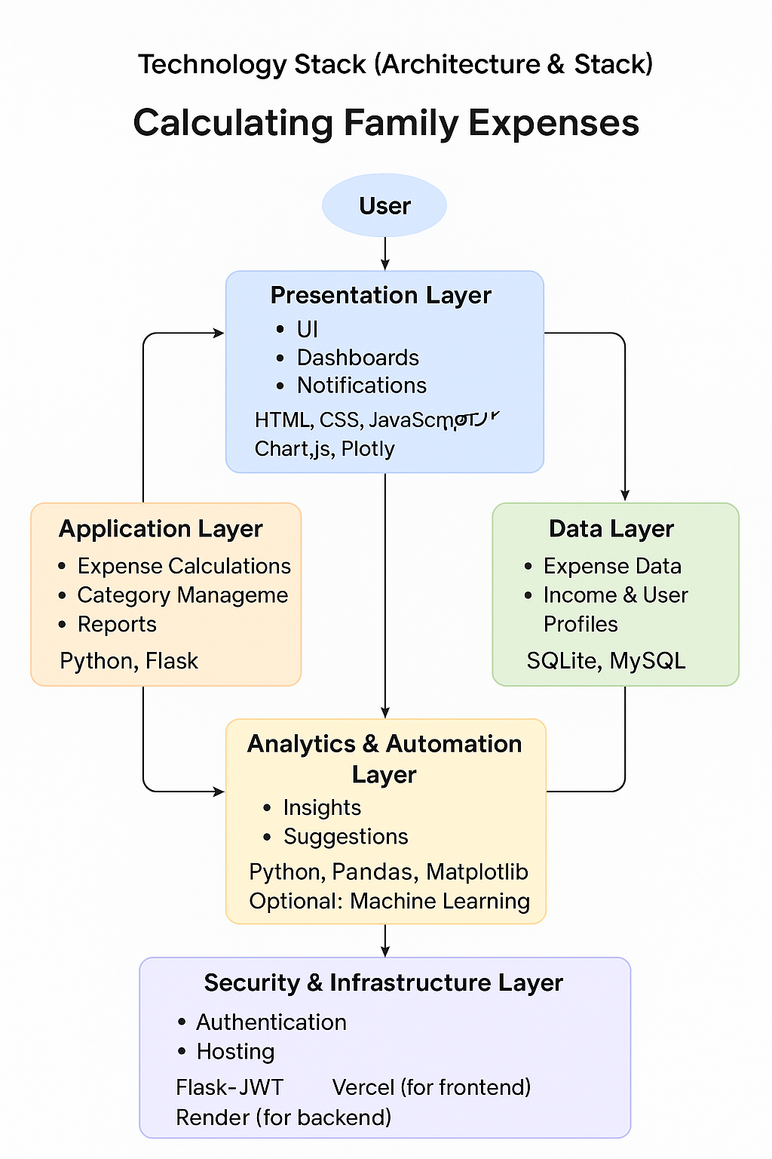

Technology Stack – Components and Technologies
Component | Technology Used | Description
Frontend (Client Side) | HTML, CSS, JavaScript | Builds the user interface for inputting, viewing, and analyzing expenses.
Backend (Server Side) | Flask (Python) | Manages business logic, APIs, and communication between the UI and database.
Database | SQLite / MySQL | Stores user details, expense records, categories, and reports securely.
Authentication & Security | JWT (JSON Web Token) | Provides secure user login, session management, and data protection.
Data Visualization | Chart.js / Plotly | Displays income vs. expenses and category breakdown through visual charts.
Email / Notification Service | Flask-Mail or SMTP | Sends alerts, monthly summaries, or spending limit notifications to users.
Hosting / Deployment | Vercel (Frontend), Render (Backend) | Ensures smooth deployment and accessibility of both client and server apps.
Version Control | Git & GitHub | Used for code management, collaboration, and version tracking.

Application Characteristics :
S.No | Characteristics | Description | Technology
1. | Open-Source Frameworks | Utilizes open-source technologies for flexibility and cost efficiency. | HTML, CSS, JavaScript, Flask (Python)
2. | Security Implementations | Implements user authentication, role-based access control, and encrypted data storage. | JWT Authentication, Flask Security, SSL
3. | Scalable Architecture | Designed to support multiple families and large datasets with minimal latency. | Flask REST API, SQLAlchemy, Cloud Hosting (Render)
4. | Availability | Application hosted on cloud platforms ensuring high uptime and reliability. | Render, Vercel, Cloud Database
5. | Performance | Optimized for quick data retrieval, smooth dashboard loading, and fast expense calculations. | Indexed Database Tables, Caching, Optimized Queries

